JOBSHEET 7
LOOP 1

- Objective
- Students can explain the format for writing loop programs (for, while, and do-while)
- Students can implement loop flowcharts using the Java programming language.

- Practicum
  - Experiment 1: Case Study of Student Grades in SIAKAD – FOR Loop
Trial Time: 90 minutes
In the Academic Information System (SIAKAD), a lecturer inputs grades for the Basic Programming Practical course taken by students. The lecturer wants to find the highest and lowest quiz grades among 10 students in a class. The lecturer must input the grades for each student, then determine and display the highest and lowest grades. Consider the following flowchart:
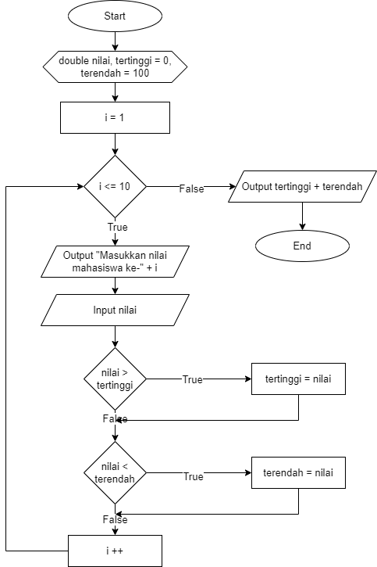
Based on the flowchart, create a program using the Java programming language.
Translated variable : nilai = grade, tertinggi = highest, terendah = lowest

- Experimental Steps
- Create a new repository on your Github account, name it daspro-jobsheet7
- Clone the repository using the git clone command from the terminal.
- Open the repository folder using Visual Studio Code
- Create a new file, name it SiakadForNoAbsen .java
- Create a basic Java program structure consisting of the main() function .
- Add the Scanner library at the top (outside) of the class
- Make a Scanner declaration with the variable name sc inside the main() function.
- Declare the variables grade, highest, and lowest using double data type. Initialize highest to 0 and lowest to 100.
- Create a FOR loop structure with a condition limit according to the number of students, 10.
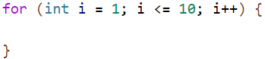
- Inside the FOR loop, add a command to enter the student's grades . Then, create two separate selection conditions to check for the highest and lowest grades by comparing the input values to the highest and lowest variables.
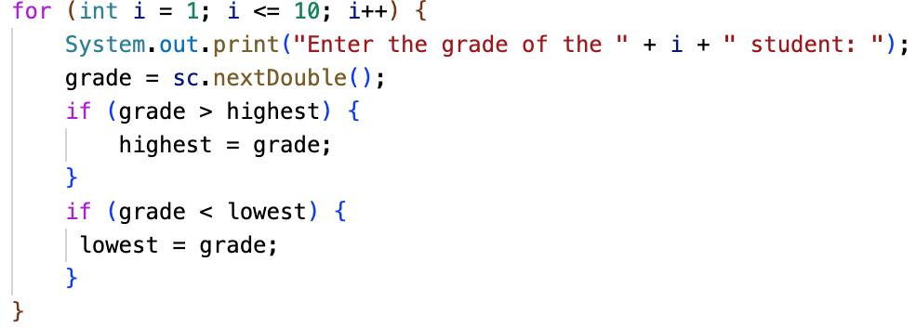
- Outside the FOR loop, display the highest and lowest values.
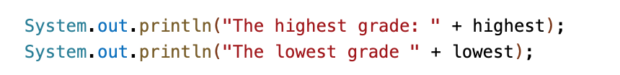
- Compile and run the program
- Commit and push the program code to Github

- Verification of Experimental Results
Match the results of compiling your program code with the following image.

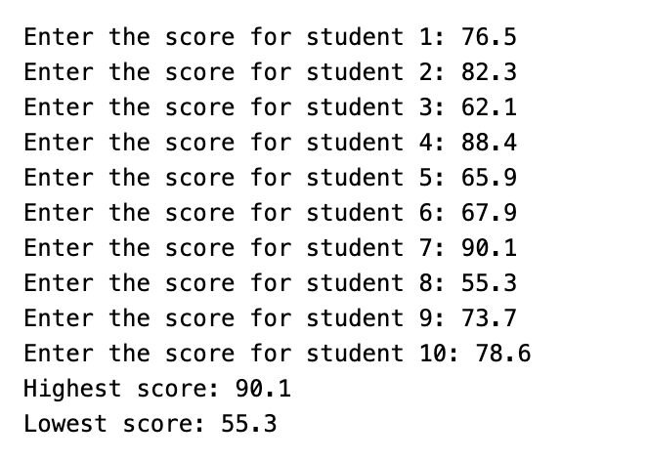
- Question
- State and show each component of the FOR loop in the program code for Experiment 1!
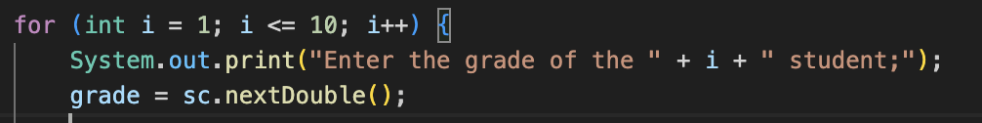

- Why is highest variable initialized to 0 and the lowest to 100? What happens if the highest variable is initialized to 100 and the lowest to 0?
highest = 0 ensures any real grade will be higher.
lowest = 100 ensures any real grade will be lower.
If you reverse them, the program never updates because no grade is higher than 100 or lower than 0.

- Explain the function and workflow of the following code snippet!
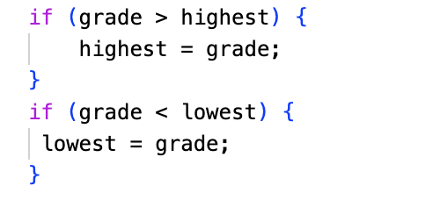
The code checks each grade.
If a grade is higher than the current highest, it replaces it.
If a grade is lower than the current lowest, it replaces it.
This finds the max and min values.

- Modify the program so that it counts how many students pass and fail based on a passing threshold (minimum grade of 60). Display the number of students who passed and failed after displaying the highest and lowest grades.
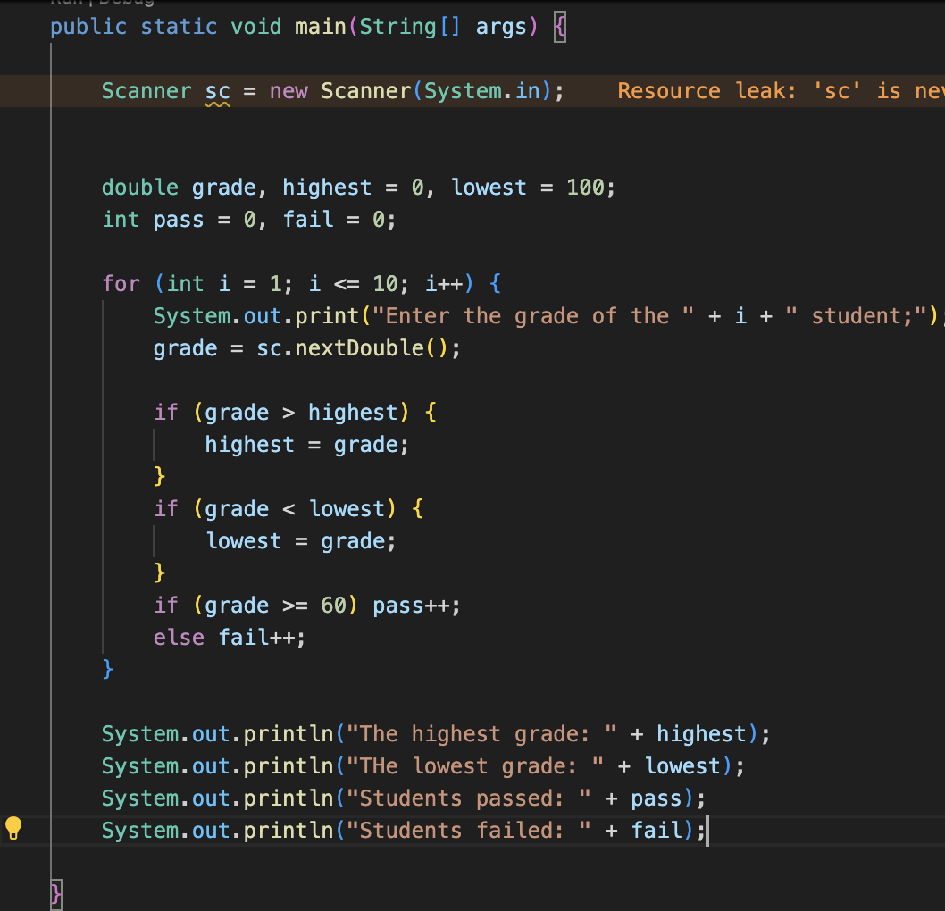
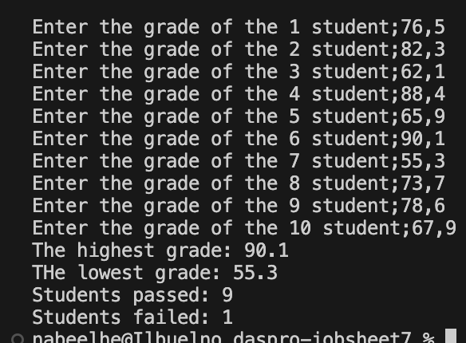
- Commit and push the program code to Github

  - Experiment 2: Case Study of Student Grades in SIAKAD – WHILE Loop
Trial Time: 90 minutes
A lecturer wants to input the grades of several students into SIAKAD to determine their letter grade categories. The program must ask the lecturer to input each student's grade. If the lecturer inputs an invalid grade (negative or greater than 100), the program must ignore the input and ask the lecturer to re-enter it. Next, valid grades are grouped into letter categories A (80 < grade ≤ 100), B+ (73 < grade ≤ 80), B (65 < grade ≤ 73), C+ (60 < grade ≤ 65), C (50 < grade ≤ 60), D (39 < grade ≤ 50), and E (grade ≤ 39).
Based on the case study, create a program using the Java programming language.

- Experimental Steps
- Create a new file, name it SiakadWhileNoAbsen.java
- Create a basic Java program structure consisting of the main() function .
- Add the Scanner library at the top (outside) of the class
- Make a Scanner declaration with the variable name sc inside the main() function.
- Declare the variables grade, total, and i (for the loop) of type integer. Initialize i with 0 as the initial value of the loop.
- Write a program code to accept the number of students input, stored in the total variable . This will dynamically adjust the loop limit based on user input via the keyboard.
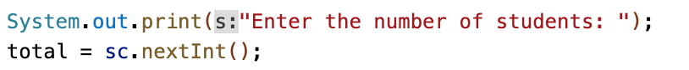
- Create a WHILE loop structure with a condition limit according to the number of students, namely 5. Note that the symbol used is < because the looping of the variable i starts from 0, not 1.
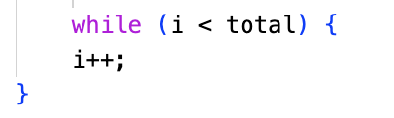
- Inside the WHILE loop, add a command to enter student grade. Next, create an IF condition to check whether the entered grades are valid, with the requirement that the grades fall within the range of 0 to 100. Then, add an IF-ELSE condition to display the letter grade categories based on the criteria.
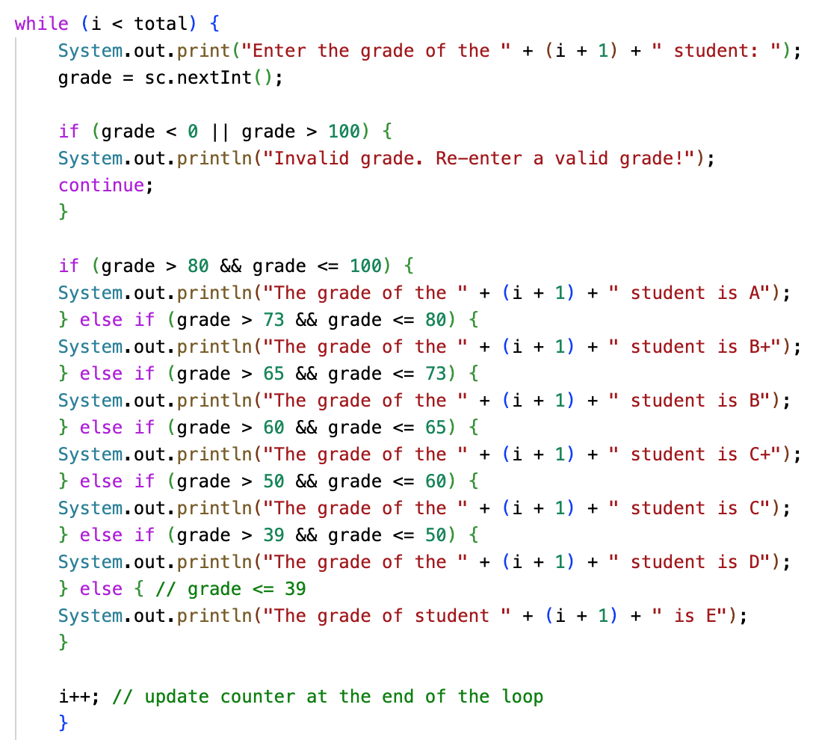

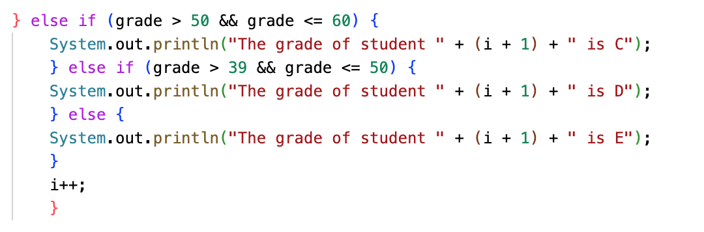
- Compile and run the program
- Commit and push the program code to Github
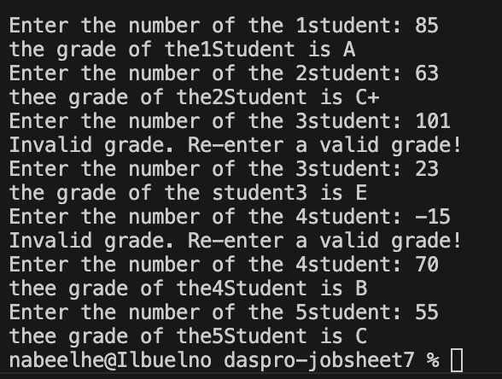

- Experimental Steps
Match the results of compiling your program code with the following image.
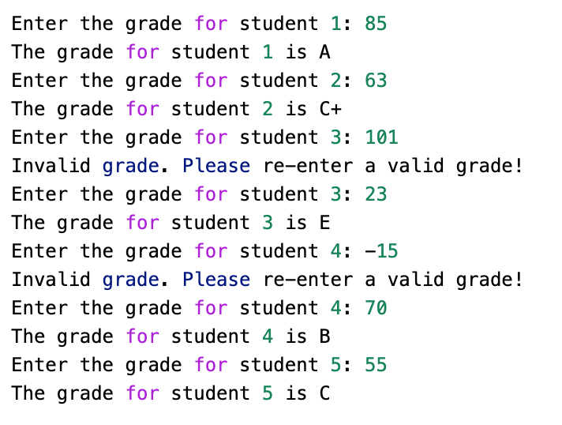
- Question
- In the following code snippet, determine the purpose and use of the following syntax:
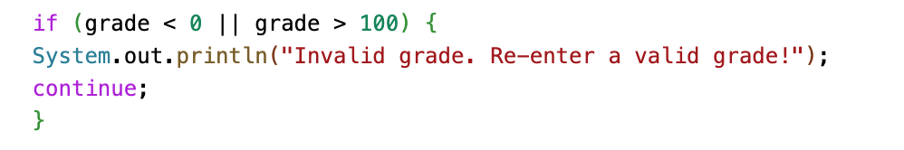
  - value < 0 || value > 100
This checks whether the input is outside the valid range. The operator || means the condition is true if either side is true.

- Continue
This skips the rest of the current loop body. The loop immediately moves to the next iteration.
- Why is the i++ syntax written at the end of the WHILE loop? What happens if its position is written at the beginning of the WHILE loop?
i++ is placed at the end so the program counts one student after finishing the grade check.
If i++ is placed at the beginning, the program increases the counter before processing. The program will skip the first student input and the flow becomes incorrect.
- If the number of students entered is 19, how many times will the WHILE loop run?
If the number of students is 19, the WHILE loop runs 19 times.
- Modify the program code so that if a student gets an A, the program displays the additional message "Good, keep the grade"!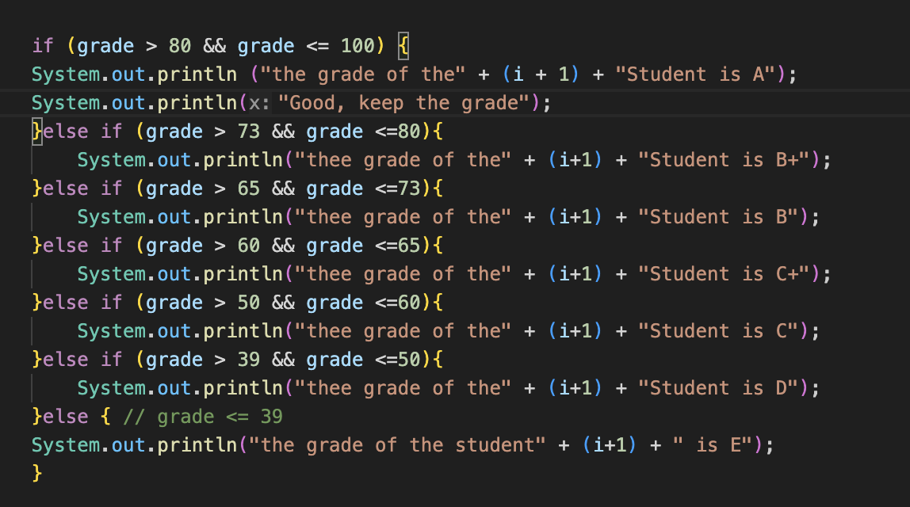
- Commit and push the program code to Github
  - Experiment 3: Case Study of Transactions in a Cafe – DO-WHILE Loop
Trial Time: 60 minutes
In a cafe, the cashier wants to process transactions for several customers. Customers may purchase more than one item ( coffee for Rp 12,000, tea for Rp 7,000, and bread for Rp 20,000 ), and the cashier will continuously enter the purchase amount for each customer. If a customer decides to cancel the transaction (by entering "cancel"), the cashier will stop inputting the transaction and the program will stop.
Based on the case study, create a program using the Java programming language.
- Experimental Steps
- Create a new file, name it KafeDoWhileNoAbsen.java
- Create a basic Java program structure consisting of the main() function .
- Add the Scanner library at the top (outside) of the class
- Make a Scanner declaration with the variable name sc inside the main() function.
- Declare the variables coffee, tea, and bread of type integer to store the number of items purchased by the customer, and customerName of type String. Declare and initialize coffeePrice with 12000, teaPrice with 7000, breadPrice with 20000.
- Create a DO-WHILE loop structure with a true condition
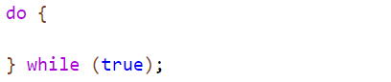
- Inside the DO-WHILE loop, add a command to enter the customerName . Then, add an IF condition to check the contents of the customerName variable . Next, add a command to enter the number of items the customer purchased for each menu item, if the customer name input is not "cancel". Calculate the total purchase price and display the result.
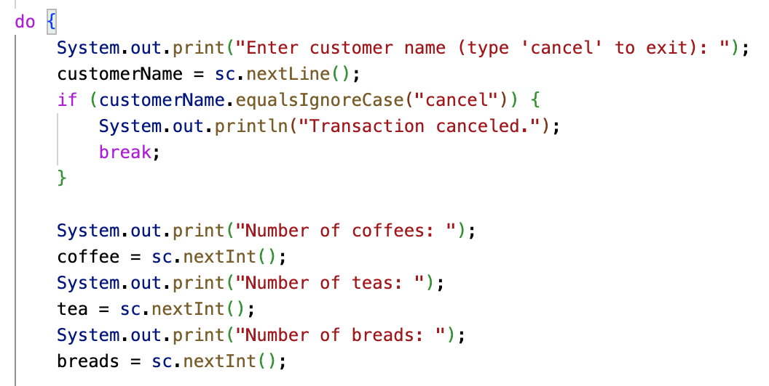

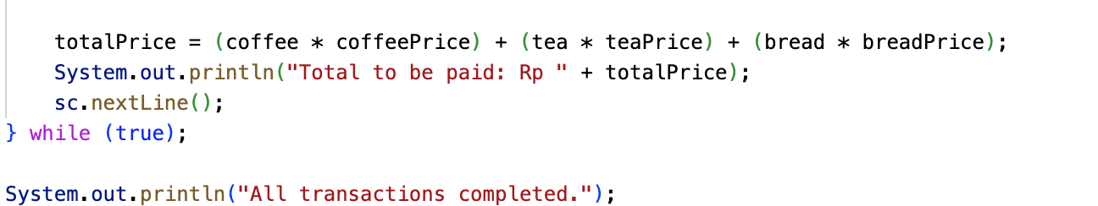
Description: sc.nextLine(); after print totalPrice is the syntax to clear newlines from the buffer.
- Compile and run the program
- Commit and push the program code to Github
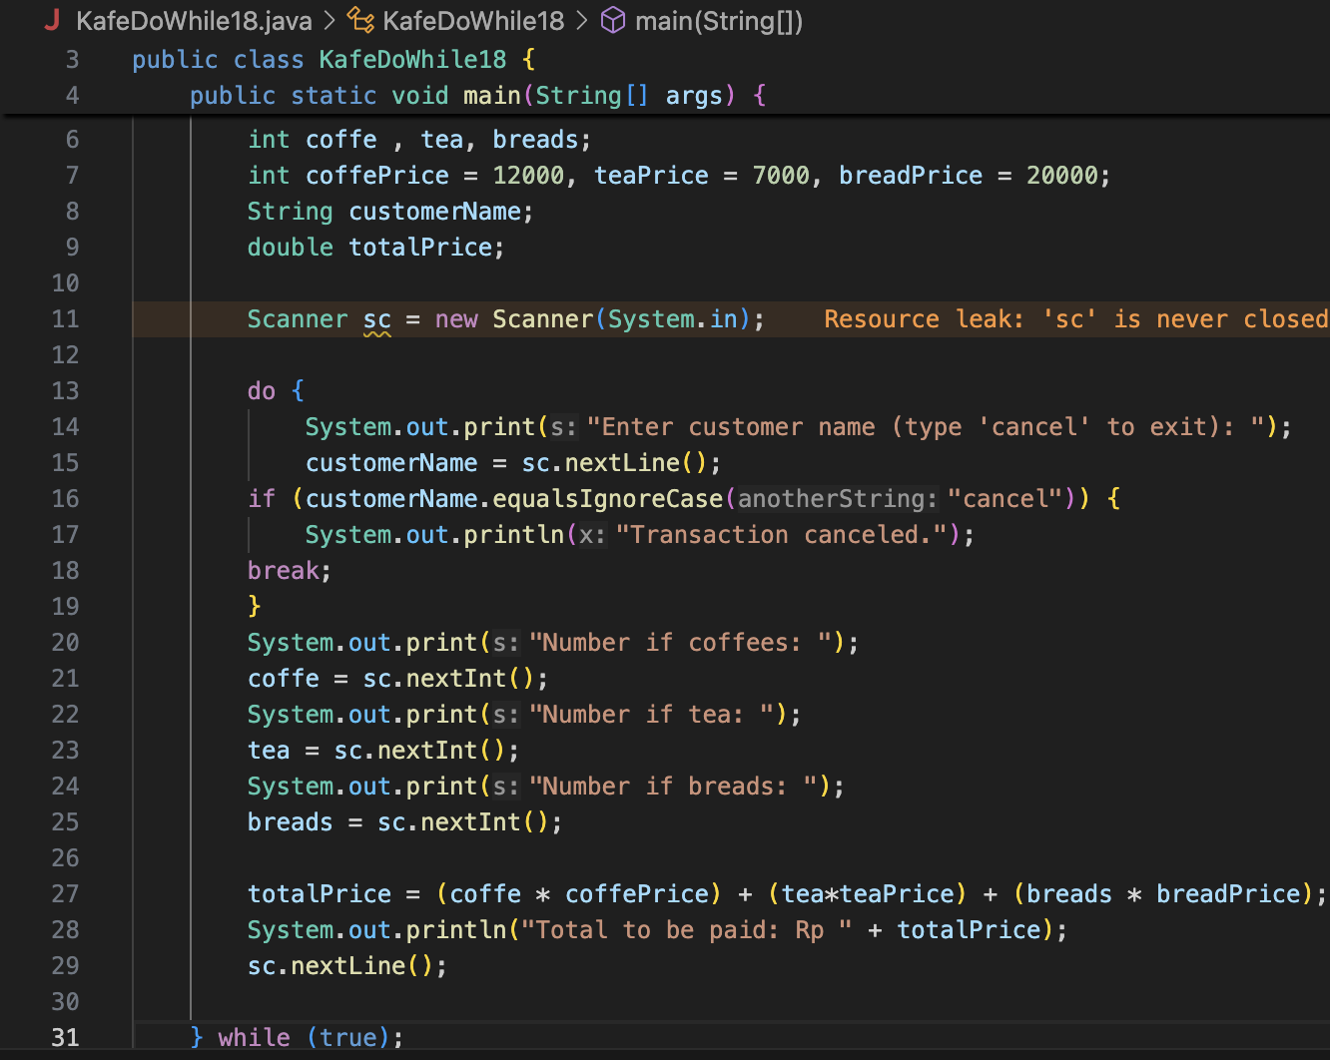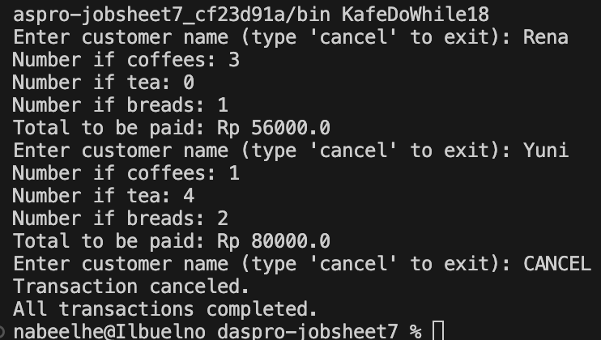
- Experimental Steps
Match the results of compiling your program code with the following image.
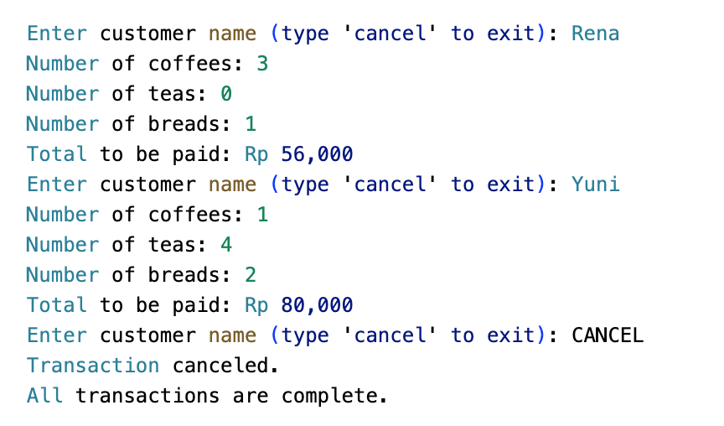
- Question

- When using DO-WHILE, if the first customer name entered is "cancel", then how many times is the loop repeated?
The loop runs once. The program enters the do block. It asks for the customer name. You type cancel. The program executes break. The loop does not repeat after that.
- State the stopping condition used in the DO-WHILE loop!
The stopping condition is the break statement. Break runs when the customer name equals cancel.

- What is the function of using the true value in the DO-WHILE condition?
The true value makes the loop unlimited. You control the stop using break. This gives flexibility because the stop condition is handled inside the logic.

- Why does the DO-WHILE loop continue to run even though there are no initialization and update components?
The do while loop does not need initialization or update in the header. You manage the variables inside the do block. The loop keeps running because the condition is true. The program stops only when break is executed inside the loop.

- Task
Trial Time: 120 Minutes
- A cinema manager wants to create a program to calculate total ticket sales for a single day. Tickets are sold at Rp 50,000 per ticket. The program must calculate the total number of tickets sold and the total ticket sales price for the day, with the following conditions:
  - If a customer buys more than 4 tickets, the customer gets a 10% discount.
  - If customers buy more than 10 tickets, customers get a 15% discount.
  - If the ticket amount input is invalid (negative), the program will ignore the input and ask for re-input.
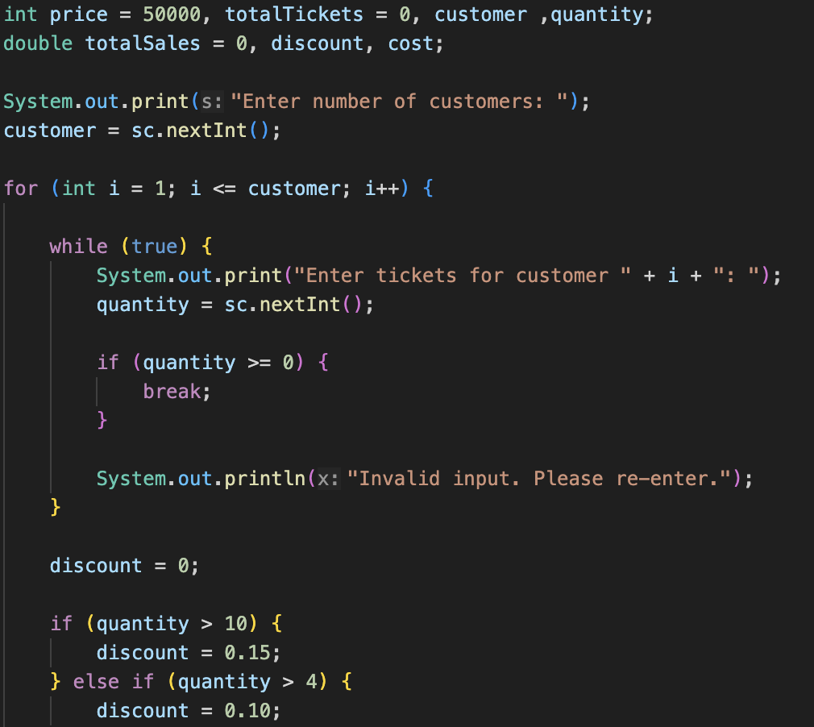
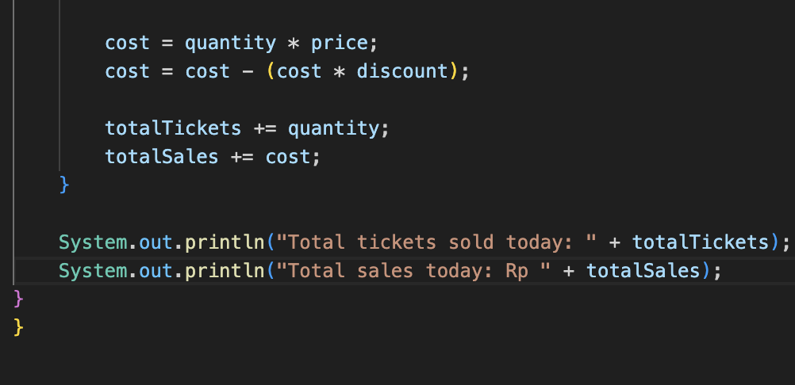
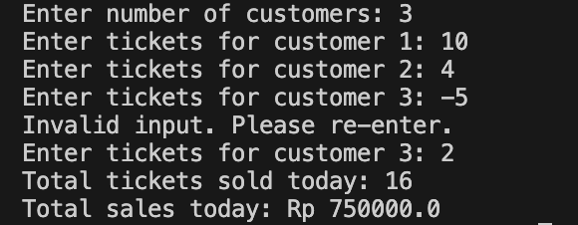
Note: Loops can use for, while, or do-while statements. Add break or continue statements if necessary.
- Pay attention to the following flowchart!
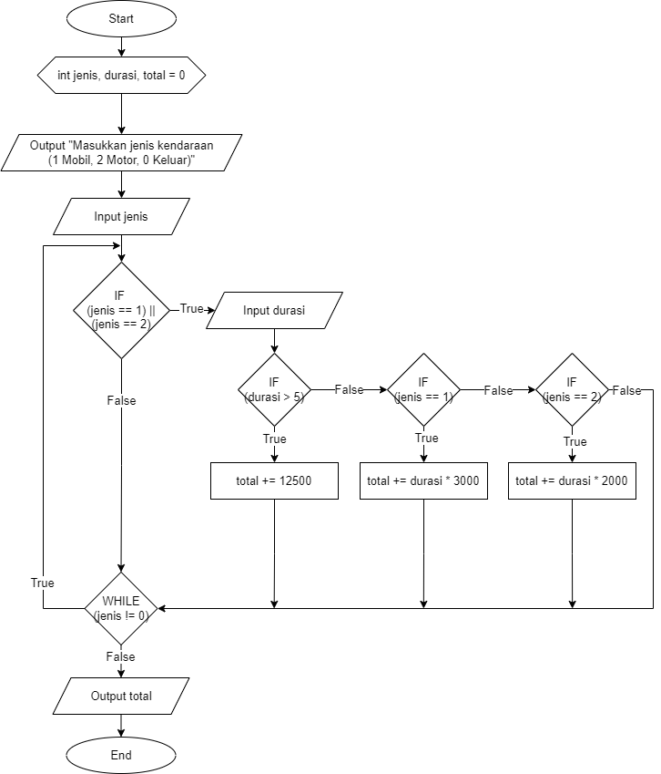
A parking lot wants to create a program to calculate the total parking fee for several vehicles. The parking rate is Rp 3,000 per hour for cars and Rp 2,000 per hour for motorcycles. However, if the parking duration exceeds 5 hours, a fixed rate of Rp 12,500 is applied to all vehicles. The program will continue to ask for input as long as the input is not 0. Implement this flowchart in Java code!
